"Conference on Universal Algebra and Lattice Theory"

Hotel accommodation booking form
Tisza Hotel***
Szeged

Please complete this booking form as soon as possible and return it to Tisza Hotel***.

RESERVATION DETAILS
Please complete one form per room
APPARTMENT:
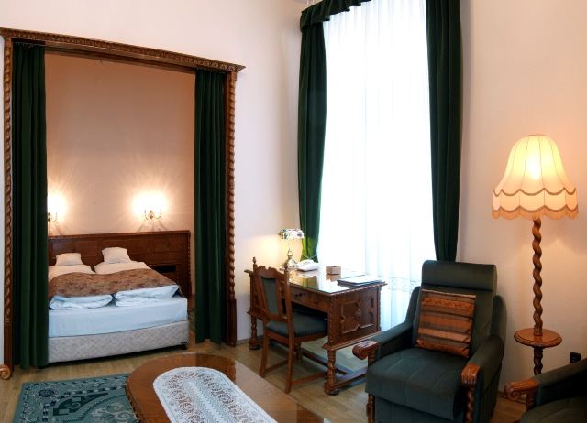
Double Apartment for single use:  rate: 19.900.-HUF or 77.-Eur/ night

Double Apartment for 2 pers.:  rate: 24.900.-HUF or 95 Eur / night

Apartment for 3 pers.:  rate: 27.900.-HUF or 108.-Eur / night

Apartment for 4 pers.:  rate: 29.900.-HUF or 115.-Eur/ night

Apartment equipment:: Double room with a living room and a retractable couch, colonial style furniture, bathroom, color TV, minibar, telephone, CARDO mattress, air conditioner. Wifi internet is available in the room.
..........................................................................................................................................................................
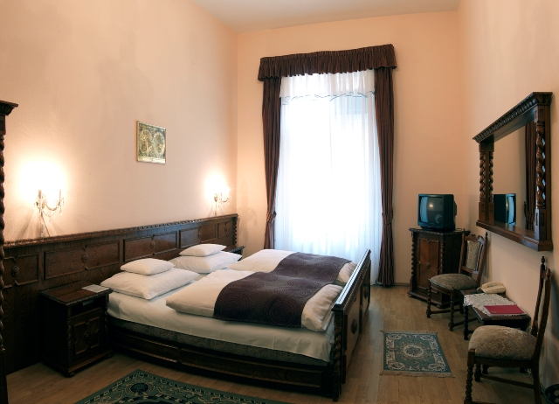
SUPERIOR ROOM:

Superior double room for single use:  rate: 14.000.-HUF or 54.-Eur/ night

Superior double room for 2 pers.:  rate: 18.900.-HUF or 73.-Eur / night

Superior room equipment:: Double / Twin room, colonial style furniture, bathroom, color TV, minibar, telephone, CARDO mattress, air conditioner. Wifi internet is available in the room.
..........................................................................................................................................................................
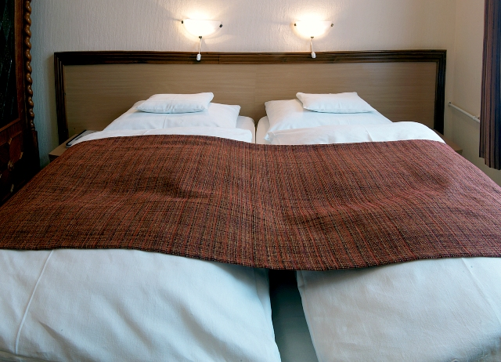
CLASSIC ROOM:

Classic double room for single use:  rate: 11.900.-HUF or 46.-Eur/ night

Classic double room for 2 pers.:  rate: 15.500.-HUF or 60.-Eur / night

Classic room equipment:: Double / Twin room, modern furniture, bathroom, color TV, minibar, telephone, CARDO mattress, air conditioner. Wifi internet is available in the room.
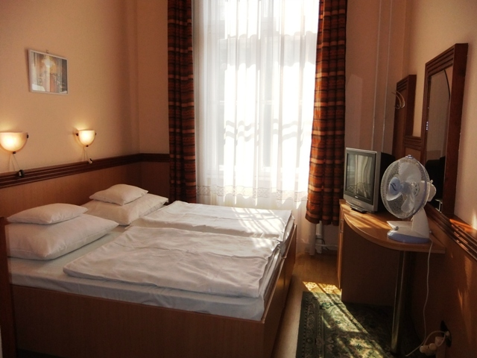
..........................................................................................................................................................................
STANDARD ROOM:

Standard double/triple room for single use:  rate: 10.400.-HUF or 40.-Eur/ night

Standard double/triple room for 2 pers.:  rate: 14.000.-HUF or 54.-Eur / night

Standard triple room for 3 pers.:  rate: 15.900.-HUF or 62.-Eur/ night

Standard room equipment: Modern furniture, bathroom with shower, color TV, minibar, telephone, CARDO mattress. Wifi internet is available in the room.

Please tick the convenient room type
Prices include buffet breakfast, wifi internet, but do not include Tourist tax of 427.-Huf/pers./night.
Children in the room of their parents under the age of 9 receive accommodation with breakfast for free. Between 9 and 12 children receive a 50% discount (not for extra bed) of the accommodation with breakfast.

GUEST DATA

First name: __________________________________________________
Last name: _________________________________________________
Address: ______________________________
Tel.: _______________ Fax.: _______________ E-mail: _____
Name of accompanying person: _____________________________

Number of guests:
Adult(s): ________________
Child(ren): ______________ Age(s): ________________

Arrival date: ________________
Departure date: ______________
No. of nights: _______________
Please let us know if your invoice address is different than your home address.
The Customer: (name and address):
........................................................................................................................................................................................................................................................................................................................................................
Payment:
- Credit Card guarantee is required.
Credit Card Company: ______________
Number: ____________ Exp. Date: _________________
CVC Code: __________________________
Card holders name: __________________________
-Payment: at the reception upon arrival in cash (HUF) or by credit card.

Note:
--------------------------------------------------------------------------------------------------------------------------------------------------------------------------------------------------------------------------------------------------------------------------------------------------------------------------------------------------------------------------------------------------------------------------------------------------------------------------------------------------------------------------------------------------------------------------------------------------------------------------------------------------------------------
I accept the conditions.

Date:__________________________________________________
Signature

BOOKING / PAYMENT INFORMATION

Payment:
■ credit card details are required for reservation guarantee.
■ accommodation fee is due to be paid at the reception upon arrival in cash (HUF) or by credit card.
- Cancellation policy:
- Free of charge cancellation is possible 7 day prior arrival
- If cancelled 7 – 1 days prior arrival or in case of No Show the 1st nights stay will be charged as a cancellation fee.

- After receiving your order, our colleague will confirm your booking.

- The booking is valid only with the confirmation of the hotel.

- Check-in time: from 14:00, check-out: until 10:00

MAIL/FAX THIS FORM AS SOON AS POSSIBLE TO
Tisza Hotel*** :
Szeged, Széchenyi square 3., Hungary
Tel./Fax: +36-62/478-278
e-mail: info@tiszahotel.hu
www.tiszahotel.hu

